Revelstoke Heritage Railway Society
Summarized COVID Safety Plan
June 23, 2020

1.0 Risk Assessment

Our Risk Assessment included the following steps:
- Involving Board members, employees and volunteers in the development of this plan
- Identifying areas where people gather, e.g.:
  - Revelstoke Railway Museum: Interior and exterior entrance / ticket purchase area; museum store; museum galleries; interior and exterior benches; Locomotive No. 5648 cab; Car No. 4; some passageways and hallways; theatre; queueing areas (e.g. locomotive simulator); model railway; Rotary Park and gazebo; office meeting room.
  - Craigallachie: Cairn; Last Spike mural; store Interior; exterior entrance.
- Identifying job tasks where workers are close to one another or the public, e.g.:
  - Revelstoke Railway Museum: Ticket and merchandise sales; interpretation in Locomotive No. 5468 cab; meetings in offices and meeting room; historic equipment in restoration; vehicle travel.
  - Craigallachie: sale of merchandise; answering visitor questions.
- Identifying equipment and tools which workers share while working, e.g.:
  - Revelstoke Railway Museum: telephones; keyboards; cash register and point of sale terminal; pens; ladders; power and hand tools; faucets; vacuum cleaner.
  - Craigallachie: telephone; cash register and point of sale terminal; pens; ladders.
- Identifying surfaces that people touch often, e.g.
  - Revelstoke Railway Museum: door knobs, handles and panic bars; elevator panel; handrails; merchandise; model railway barriers, step stools and collection box; coffee pot; refrigerator and microwave handles.
  - Craigallachie: door knobs, handles and panic bars; merchandise; coffee pot; refrigerator/freezer and microwave handles; handrails.

2.0 Protocols to Reduce Risks

Our planning included review of guidance from WorkSafe BC; peer museums; provincial and national museums associations; provincial agencies; Centers for Disease Control and Prevention (U.S.); Heritage Rail Alliance.

The following mitigations are summarized by the four prescribed levels of intervention:

Level One: Elimination
- Posting entrance signs and website asking visitors to not enter if they have been exposed, are ill, or have been potentially exposed;
- Establishing and posting occupancy limits on specific areas:
  - Revelstoke Railway Museum:
    - Total facility occupancy:
    - Museum store occupancy:
    - Gallery Three occupancy:
    - Exterior park/yard occupancy:
  - Craigallachie:
    - Store occupancy:
- Cancelling facility rentals, birthday parties, group tours at the Revelstoke Railway Museum until mitigations ensuring safe conduct can be developed gatherings are permitted

Level Two: Engineering controls to separate workers from hazards
- Entry, egress, capacity: using stanchions to enable orderly visitor entry and reduce crowding; using a single point of entry or exit at the Revelstoke Railway Museum; assigning volunteer or staff to regulate entry;
- Physical barriers: using plexiglass barriers at interaction points with visitors (e.g. ticket window, sales counter) and cleaning them regularly; re-installing the locomotive window in the Simulator
- Flow, movement, distancing: posting signage and routing arrows to maintain flow in one direction; using stanchions, marking queueing areas and 6 foot spacing lines; removing obstructions such as display cases from aisles; improving 2nd floor interpretation and spacing; closing areas where social distancing is not possible; providing designated seating areas and marking 6 foot distancing signage; closing and removing high-touch displays;
- HVAC: increasing ventilation with fans
- Office workspace: positioning desks as far apart as possible; limit of one visitor per office; limiting 4 persons in the meeting room with 6 foot spacing; using phone or zoom
- Planning: ensure projects include plans for physical distancing

Level Three: Administrative Controls – changing the way work is performed
- Entry, Egress, Capacity: restricting visitor entry to spaces; requesting one group member approach ticket window;
- Visitor Information and Conduct: encourage visitors to use PPE and sanitize hands upon entry; remind visitors to maintain physical distancing; asking visitors to follow Code of Conduct; remind visitors to use proper handwashing protocols in washroom; remove guest book and verbally obtain information at ticket purchase including phone numbers to support contact tracing; publishing our protocols and interventions on website and social media; providing visitor guide with COVID routing on request rather than being available for random handling
- Flow, Movement, Distancing: limit elevator use to persons with accessibility issues and limit capacity/or one person or cohort at a time; remove videos to reduce bunching; re-position baggage cars to reduce bunching; assign volunteers to monitor and manage flow and distancing; allow re-use of ticket all day;
- Washrooms and Drinking Fountains: provide hand sanitizer stations; prop bathroom doors open; allow visitors to bring in water and shut off water fountains; request increased cleaning of Craigallachie washrooms;
- Payment and Cash Handling: encourage non-cash payment; staff to sanitize hands after every interaction; wrap payment machine in cling film and spray after each use; isolate cash payments or donations;
- Store: bag porous merchandise (e.g. stuffed animals); post signs encouraging shoppers to ask for assistance rather than handling items; isolate returned merchandise; wipe down Craigellachie coffee service area hourly; place purchases in museum bags rather than using visitor bags;
- Simulator: require rigourous simulator protocol with hand sterilization and simulator wipe down before and after each use;
- Staff Instruction: provide individual copies and group briefing before opening; train and empower staff on interventions and protocols; all staff to model the desired behaviours;
- Collections: post no-touch signs on artifacts which cannot be cleaned; use gloves to handle artifacts or wash hands with soap and water before handling; isolate newly-arrived objects;
- Offices: wipe down keyboards between users and after workday; provide wipes and disinfectant spray; restructure archival work to reduce data entry; expand archival workspace to reduce crowding; wash hands after handling mail

Level Four: Personal Protective Equipment
- Supply masks to staff and volunteers and require it be worn in all public-facing roles at all times or whenever physical distancing cannot be maintained in any workplace
- Supply gloves in all sizes in visitor-facing areas
- Permit staff to wear their own additional PPE
- Train staff or volunteers on proper hand washing and mask use and handling
- Provide plenty of hand sanitizer for use while on the job

3.0 Cleaning and Hygiene Practices

- Contract professional janitor will clean the museum, washrooms and museum offices and coffee room nightly with particular attention to high-touch areas;
- Staff will perform four-times daily wipe-downs with disinfecting wipes or spray in their work areas and high-touch areas: door knobs, handles, panic bars; elevator panel; telephones and keyboards; photocopier; hand rails; plexiglass barriers; washroom surfaces (handles, seats); pens or other items used by visitors using disinfecting wipes before re-use
- Break room users will wipe down any surfaces touched in the break room/kitchen after use (e.g. microwave, fridge)
- Limit common use of desk surfaces and keyboards and wipe down with disinfecting wipes between users
- Reminders of handwashing protocols posted in all staff and public washrooms

4.0 Policies

Illness Policies:
- The following persons are prohibited from the museum:
  - Anyone showing symptoms of COVID-19
  - Anyone who has had symptoms in the last 10 days, including fever, chills, new or worsening cough, shortness of breath, sore throat, and new muscle aches or headache
  - Anyone who has arrived from outside of Canada, or who has had contact with a confirmed COVID-19 case
  - Anyone who is required to self-isolate
- A worker who starts to feel ill at work will be asked to wash or sanitize their hands, provided with a mask, and isolated. They will be instructed to go home immediately. If the worker is severely ill, the supervisor will call 911.
- Any surface that a sick worker came into contact with will be immediately cleaned and disinfected using disinfecting wipes and spray.
- Statutory sick leave policy per Province of BC legislation will be provided.

General Policies:
- Occupancy limits:
  - Revelstoke Railway Museum: XX persons in total
  - Revelstoke Railway Museum Store: XX persons at any given time
  - Revelstoke Railway Museum Gallery 3: XX persons
  - Craigellachie Store: XX persons
- The following areas or interactives are closed to visitors until the public health emergency is ended or cleaning protocols can be developed:

  - Kids’ caboose
  - No. 5864 locomotive cab
  - Museum theatre
  - Jack Leslie locomotive photo computer

- Facility Rentals and Group Tours: Facility rentals including birthday parties are cancelled and fees will be refunded until further notice
- Staff or volunteers traveling to Craigellachie will travel in separate vehicles. If this is not possible, masks will be worn by all occupants of the vehicle.
- Violations of the protocols or policies will be handled per the RHRS’ progressive discipline policy. Egregious violations will lead to suspension or termination of employment or volunteer duties.
- The Executive Director is empowered to ask visitors not following protocols to leave any RHRS facility. The Craigellachie store manager is empowered to ask visitors not following protocols to leave the Craigellachie store.

Collections Policies:
- Do Not Touch signs will be placed on larger artifacts or artifacts will be cordoned off
- Any donated or loaned objects (e.g. artifacts, photographs, or archival material) will be placed in a container in a designated area for ten days before being handled.
- Non-railway objects or non-railway used books will not be accepted.
- Researchers accessing any collections photographs or archives will be given vinyl or latex gloves to use and they will be discarded after use.
- Materials accessed by outside researchers will be placed in a container in a designated area for ten days before being returned to storage areas.
- Visitors will be asked to use the museum washrooms rather than the staff washroom in the museum offices

Contingency Plan for Outbreak
- Staff to notify the Executive Director
- Executive Director to close the facility immediately
- Executive Director or designate to immediately report the suspected outbreak to BC Public Health using the prescribed process
- Executive Director or designate to send staff home with masks and ask them to self-isolate pending instructions from BC Public Health
- Executive Director to notify the Executive Committee of the Board of Trustees
- Executive Director or designate to post the temporary closure on social media, google business, website, record a new phone message
- Follow cleaning protocols instructed by BC Public Health

Contingency Plan for visitors or employees displaying symptoms:
- Staff to notify the Executive Director
- Staff to isolate visitor and give them a mask (Library in Revelstoke Railway Museum)
- Executive Director or designate to contact BC Public Health
- Follow BC Public Health instructions for the visitor or employee
- Follow BC Public Health instructions for the museum and employees (e.g. closure or self-isolation)
- Executive Director to notify the Executive Committee of the Board of Trustees

Revelstoke Railway Museum – Main Floor 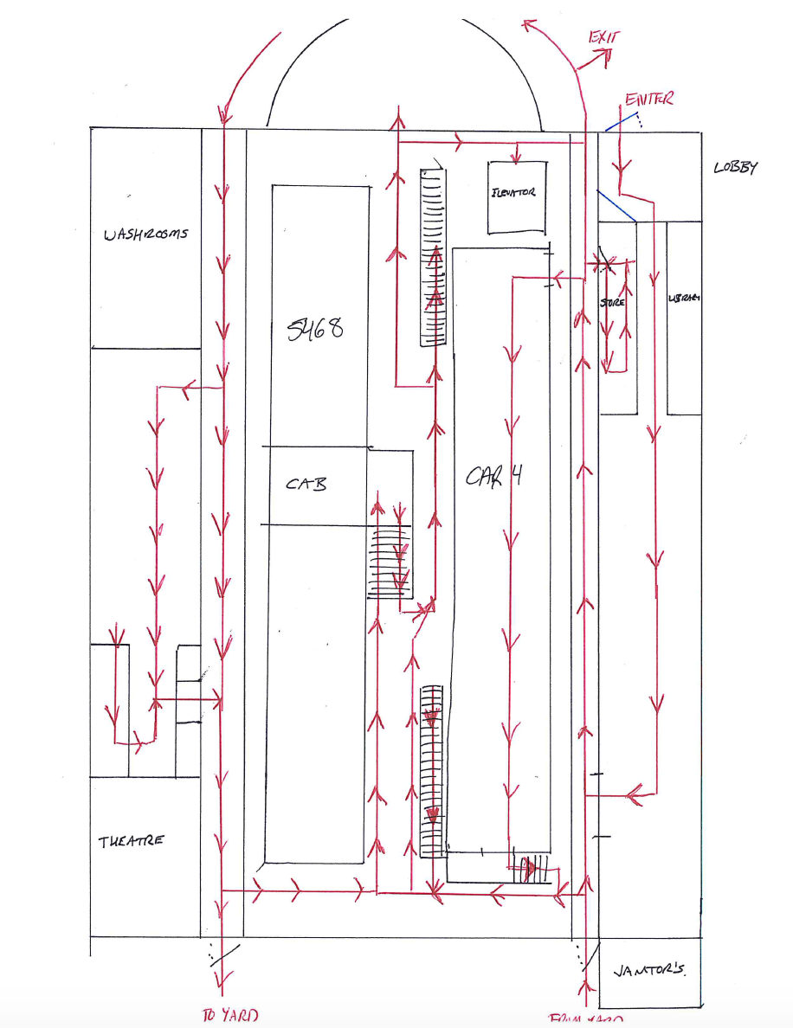

Revelstoke Railway Museum – Second Floor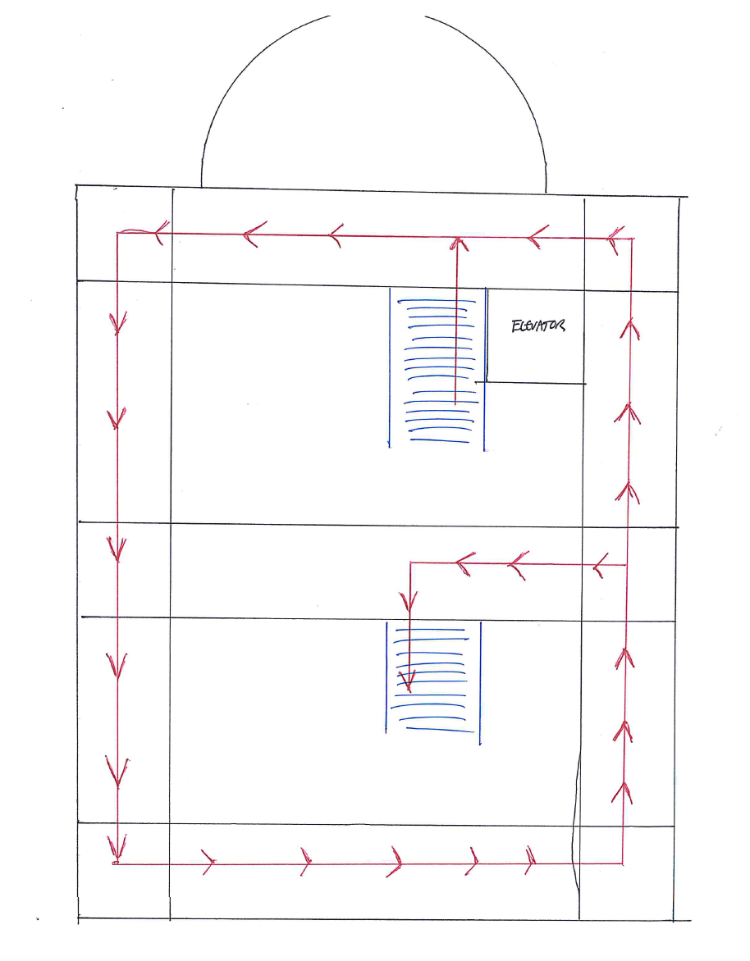

Revelstoke Railway Museum – Outside Yard
